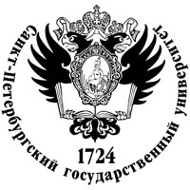

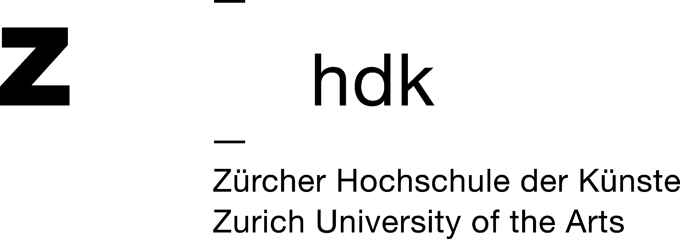**MANIFESTA 10 SUMMER SCHOOL**

**Please Mine the Gap: Between artistic research**

**and the engagement of space**

In collaboration with St Petersburg State University

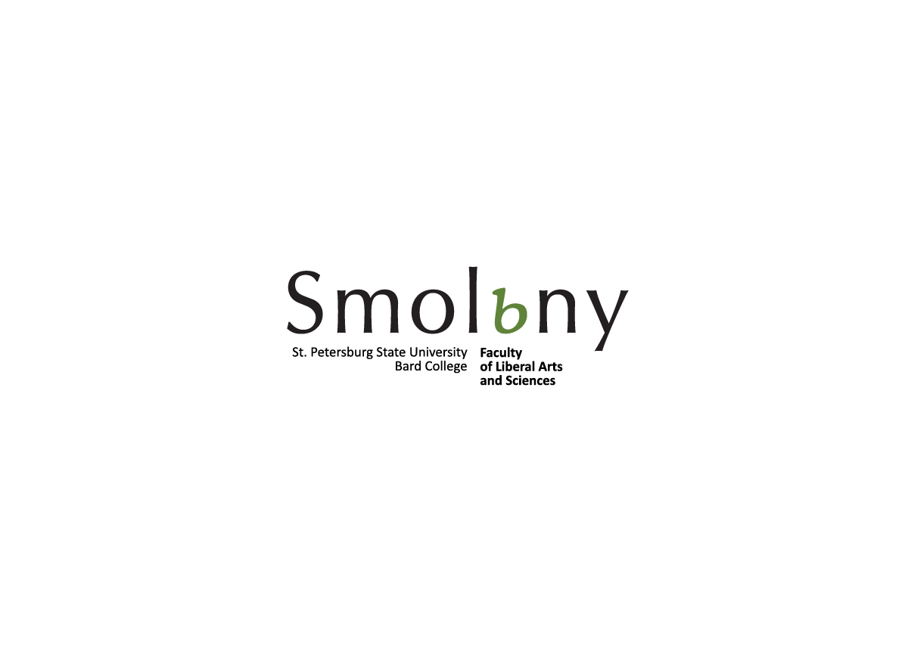and Zurich University of the Arts

St Petersburg, Russia

22 July - 3 August 2014

**Deadline** for application for participants from **St Petersburg State University**: 23 June 2014

**Deadline** for application for participants from **Zurich University of the Arts**: 16 June 2014

Only current students of St Petersburg State University and Zurich University of the Arts

are eligible to apply.

**MANIFESTA 10 Summer School** is a partnership with Manifesta 10, State St Petersburg University and ZHdK. Taking the artistic concept of Manifesta 10 as the departure point for the Manifesta 10 Summer School. The two-week programme will address how artists have enquired or engage with space through a series of lectures, seminars, workshops, field trips, screenings, artist-led walks and performances in St Petersburg led by Russian and international artists and curators. Students will be encouraged to work in groups as to encourage international exchange between the students. The programme is led by curator, writer and experimental film maker Masha Godovannaya and includes artists Thomas Hirschhorn, Kristina Norman, Alexandra Pirici, Stefan Kaigi and Flo Kaseru, among others who engage with the fabric of the city and architecture.

**gap**, noun

1. a break or opening in a wall, fence, etc
2. a break in continuity; interruption; hiatus

3. a break in a line of hills or mountains affording a route through

A ‘gap’ notionally has the potential to be filled. However the invitation to fill the gap requires further exploration. *What should fill the gap?* In order to answer this question one must look at the context in which the gap is found. What is the origin of the gap? Was it formed intentionally or did it occur naturally? The ‘gap’ offers itself as a void that is made present through its omission. This omission provides a space for investigation and imagining.

Summer School will take place at St Petersburg State University, Faculty of Liberal Arts and Sciences

St Petersburg, Galernaya str. 58-60

There is no fee to participate in the Summer School but students will be required to cover travel, accommodation and food costs.

**Language**: English

Please **download application** from the website and submit it by 23 June 2014 via email [education@manifesta.org](mailto:education@manifesta.org).

<http://manifesta10.org/media/uploads/files/M10_Summer_School_Application.docx>

If you have any enquires please telephone +7 812 416 13 03.

Summer School application results will be announced by **5 July 2014**.

[www.manifesta10.org](http://www.manifesta10.org)

**What is Manifesta?**

Manifesta is a research biennial. Every two years this research project explores Europe’s peripheries on the basis of its history, its changing identity, its urbanity, the notion of the place and its identification as a catalyst for regional communication and building up knowledge.

Manifesta has to reconfigure itself every two years as an effect of its nomadic character. Manifesta has to prove itself every two years on the basis of its site specificity. In terms of artistic research it has to prove itself by the artistic concept in relation to the use of venues as non-white cube spaces and it’s social relevance.

Manifesta is the only roving biennial in the world, changing locations every two years aiming to investigate and reflect on current developments in contemporary art. Its origin is based on addressing the disbalance in between East and West Europe after the fall of the Wall at the end of the 1980’s. Previous editions of the Manifesta Biennial have taken place in Rotterdam (Manifesta 1, 1996), Luxembourg (Manifesta 2, 1998), Ljubljana (Manifesta 3, 2000), Frankfurt (Manifesta 4, 2002), San Sebastian (Manifesta 5, 2004), Nicosia (Manifesta 6, 2006 cancelled) Trentino - South Tyrol (Manifesta 7, 2008), Murcia (Manifesta 8, 2010) and Genk, Belgium (Manifesta 9, 2012).

**The City of St Petersburg**

St Petersburg is a resilient city that is known as the cultural capital of Russia. Established in 1703 St Petersburg with the Peter Paul Fortress on the Neva River has a rich & diverse history from the founding of the city by Peter the Great, through to the October Revolution, the Siege of Leningrad, Perestroika and the renaming of the city to St Petersburg in the post Soviet era. St Petersburg has always attracted artists, composers, musicians, writers, designers, choreographers, dancers and architects including the Avant Garde artist Kazimir Malevich, architect El Lissitsky to artists Timur Novikov and Vladislav Mamyshev Monroe.

Today the city of St Petersburg is a busy city with over 5 million inhabitants. Forging forward with the new State Hermitage Museum venue the General Staff Building, the home of modern and contemporary art. Manifesta 10 the European Biennial of Contemporary Art launches the new venue in the City of St Petersburg.

**MANIFESTA 10**

In 2014 Manifesta goes back to its origins as a cultural bridge between the West and the East. By choosing St. Petersburg and the State Hermitage Museum as main collaborators for MANIFESTA 10, the Biennial ventures beyond Europe’s borders for the first time. Manifesta is interested in exploring the potential of European dialogue and aspires to provide a moving platform for experimentation to artists and professionals who might otherwise have limited access to the dominant centres of contemporary art. At the same time, Manifesta wishes to raise historical consciousness in the region where it is hosted and to encourage awareness on the role of contemporary art in today’s society.

**Curatorial Framework**

“Since Saint Petersburg regained its name,” the working title of the proposal of Kasper König posits that notionally a historical gap, the once named city of St Petersburg loses and then regains its name. The proposal not only points towards a gap between the historical and the contemporary in the cities history but also to the acquisition of artworks within the collection of the State Hermitage Museum. Gaps are synonymous with collections of art. However the contemporary artworks that the curator wishes to propose at the State Hermitage Museum have been made within the last 25 years. Therefore the curator sees this lack as opportunity ‘to take advantage of them’ to review the gap to be filled with contemporary art so to create a dialogue between the contemporary and the historical collection. König also proposes to use the gap as a curatorial tool; a space to reflect upon contemporary practice that has created an impact in shaping the current generation. The significance of the last 25 years holds a particular resonance within Europe as the former East and West formulate a multiple identity and is also the spirit in which Manifesta emerged as a response to the end of the Cold War. Manifesta now coming of age as an established European Biennial will celebrate its 10th edition for the first time in the context of a museum.