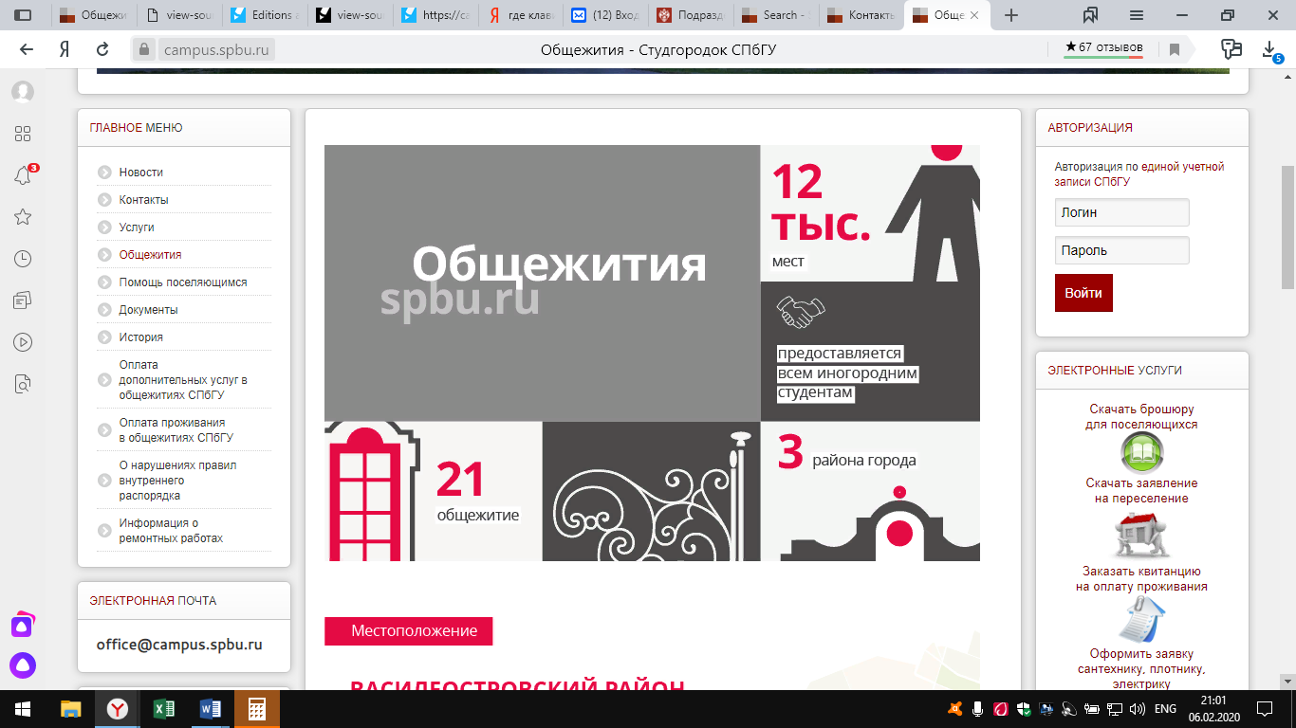

Halls of Residence 12,000 availabilities
provided to all nonresidents
21 Halls of Residence in 3 city districts

Location

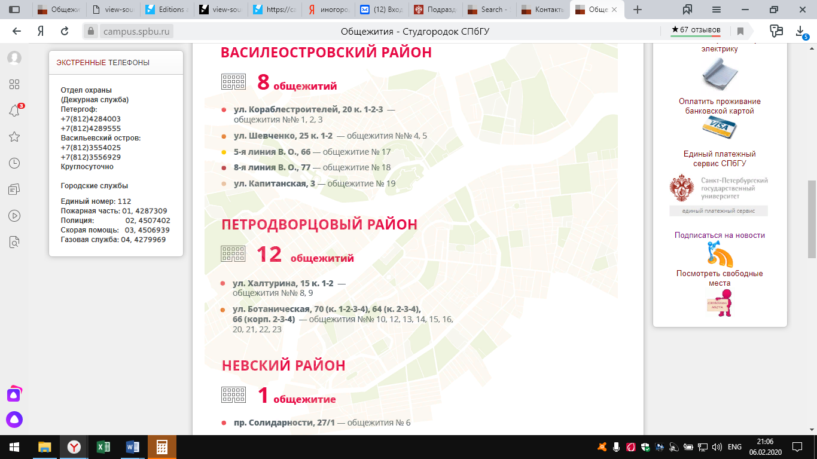
Vasilievsky Island District
8 halls of residence
Korablestroiteley Street, 20/1-2-3 Halls of residence No.1,2,3
Shevchenko Street. 25/1-2 Halls of residence No. 4,5
5th line, V.O. Hall of residence No. 17
8th line, V.O. Hall of residence No. 18
Kapitanskaya Street Hall of residence No. 19
Peterhof
12 halls of residence
Khalturina Street, 15/1-2 Halls of residence No. 8,9
Botanicheskaya Street, 70 Halls of residence No. 10,12,13,14,15,16,20,21,22,23
Nevsky District
1 hall of residence
Solidarnosti Avenue, 27/1 Hall of residence No. 6

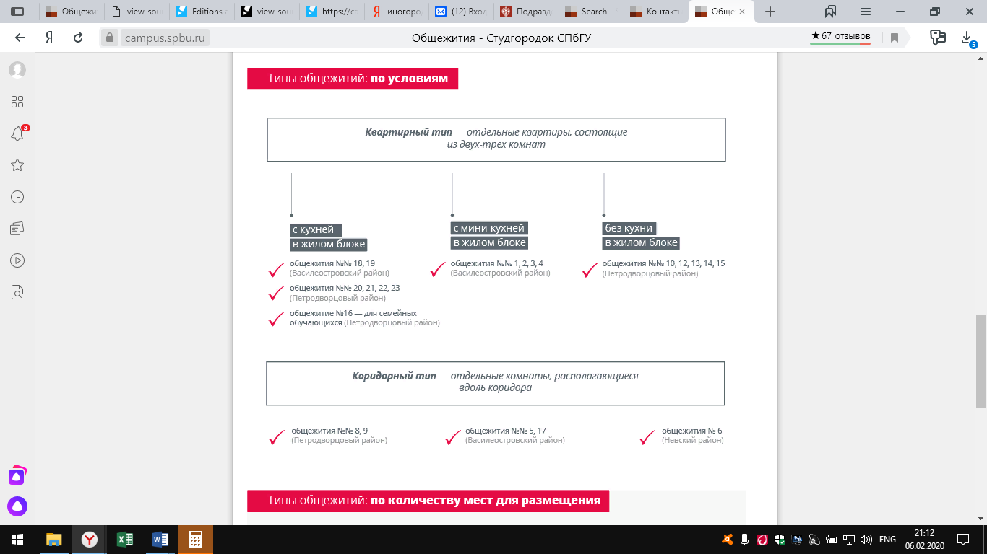
Types of accommodation in the halls of residence
Apartment type – separate apartments with 2-3 bedrooms
With kitchen in the living cluster with kitchenet in the living cluster no kitchen in the living
Cluster
Halsl of residence No. 18, 19 No. 1,2,3,4, No. 10,12,13,14,15
Vasilievsky District Vasilievsky District Peterhof
Halls of residence No. 20,21,22,23
Peterhof
Hall of residence No. 16 – for married
Peterhof
Corridor type – separate rooms from one corridor
Halls of residence No. 8,9 No. 5,17 No. 6
Peterhof Peterhof Nevsky District
Type of the halls of residence by capacity

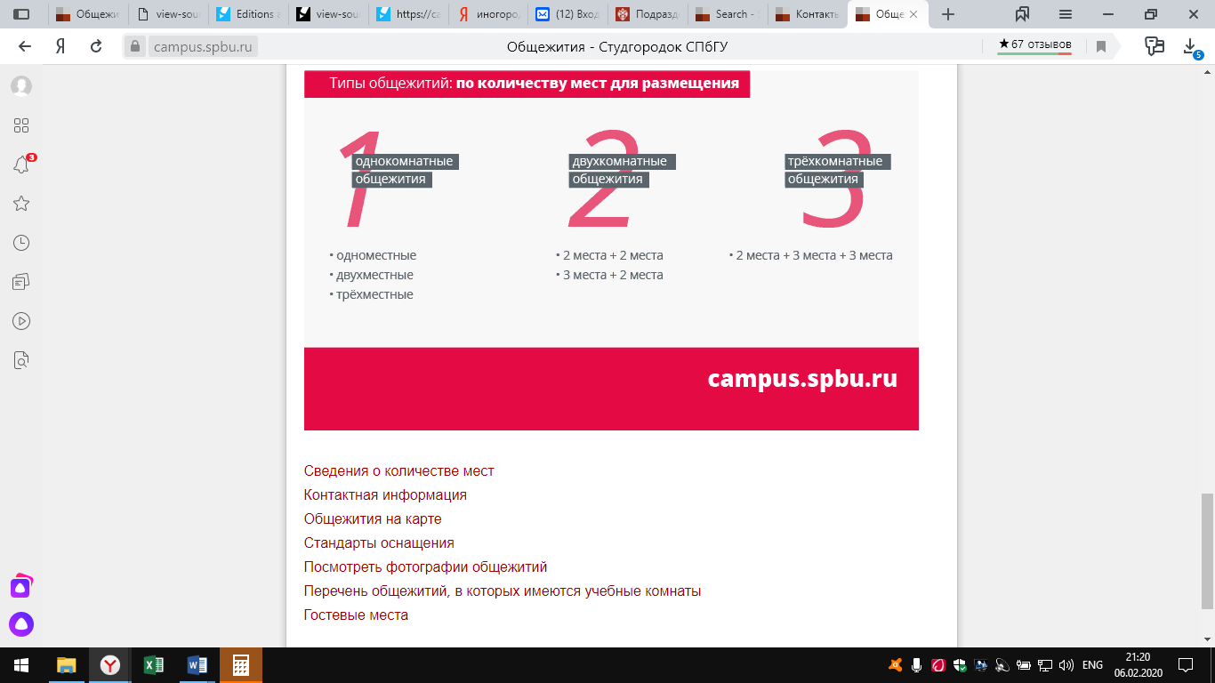
Type by capacity
One bedroom two-bedroom three-bedroom
Single 2 + 2 living places 2 + 3 + 3 living places
Double 3 + 2 living places
Triple

Availability
Contact details
Hall of residence on the map
Standads of accommodation
Halls of residence picture gallary
List of halls of residence with rooms to study
Third parties lodging

